UNIVERSITY OF ENGINEERING AND TECHNOLOGY, PESHAWAR
Department of Computer Science

DATA STRUCTURE LAB

Lab Task 5: Linked Lists
Pointers • Structures • Dynamic Memory • Nodes • Chaining • Traversal

Submitted by | Anas Khan
Registration No. | 1691
Section | B
Program | Computer Science
Course | Data Structure Lab
Week / Lab | Week 5 / Lab Task 5
Submitted to | Sir Mudassir Ahmad Khan
University | University of Engineering and Technology, Peshawar

TASK 1: Modify a Value Through a Pointer
Task Statement: Read an integer into a variable, create a pointer to it, then add 10 to the value by using only the pointer for the modification. Display the value before and after modification.
Program:
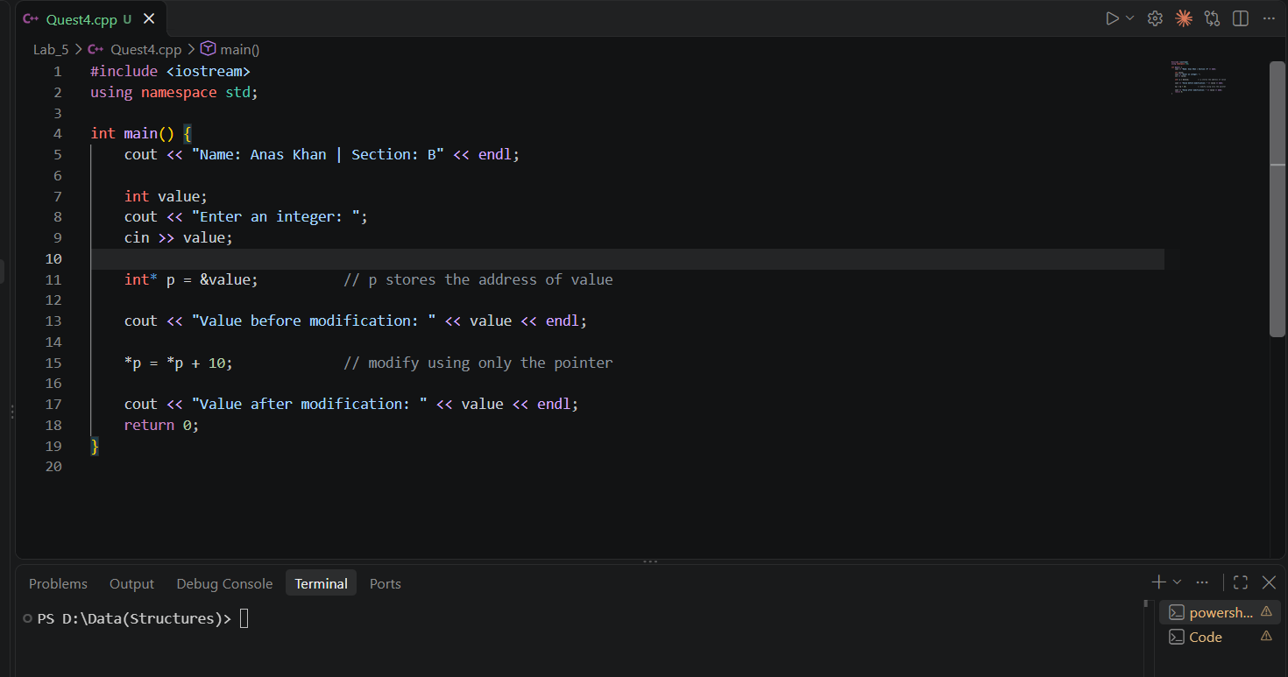

Console Output Screenshot:
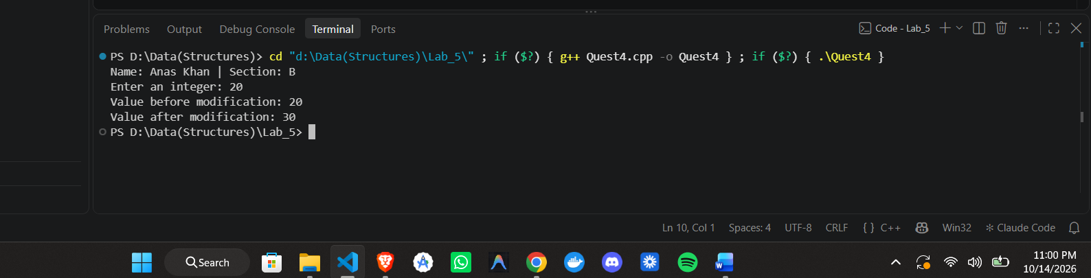

TASK 2: Create and Display a Student Structure
Task Statement: Define a Student with name, age, rollNo, and marks. Take the values from the user and display the complete record.
Program:
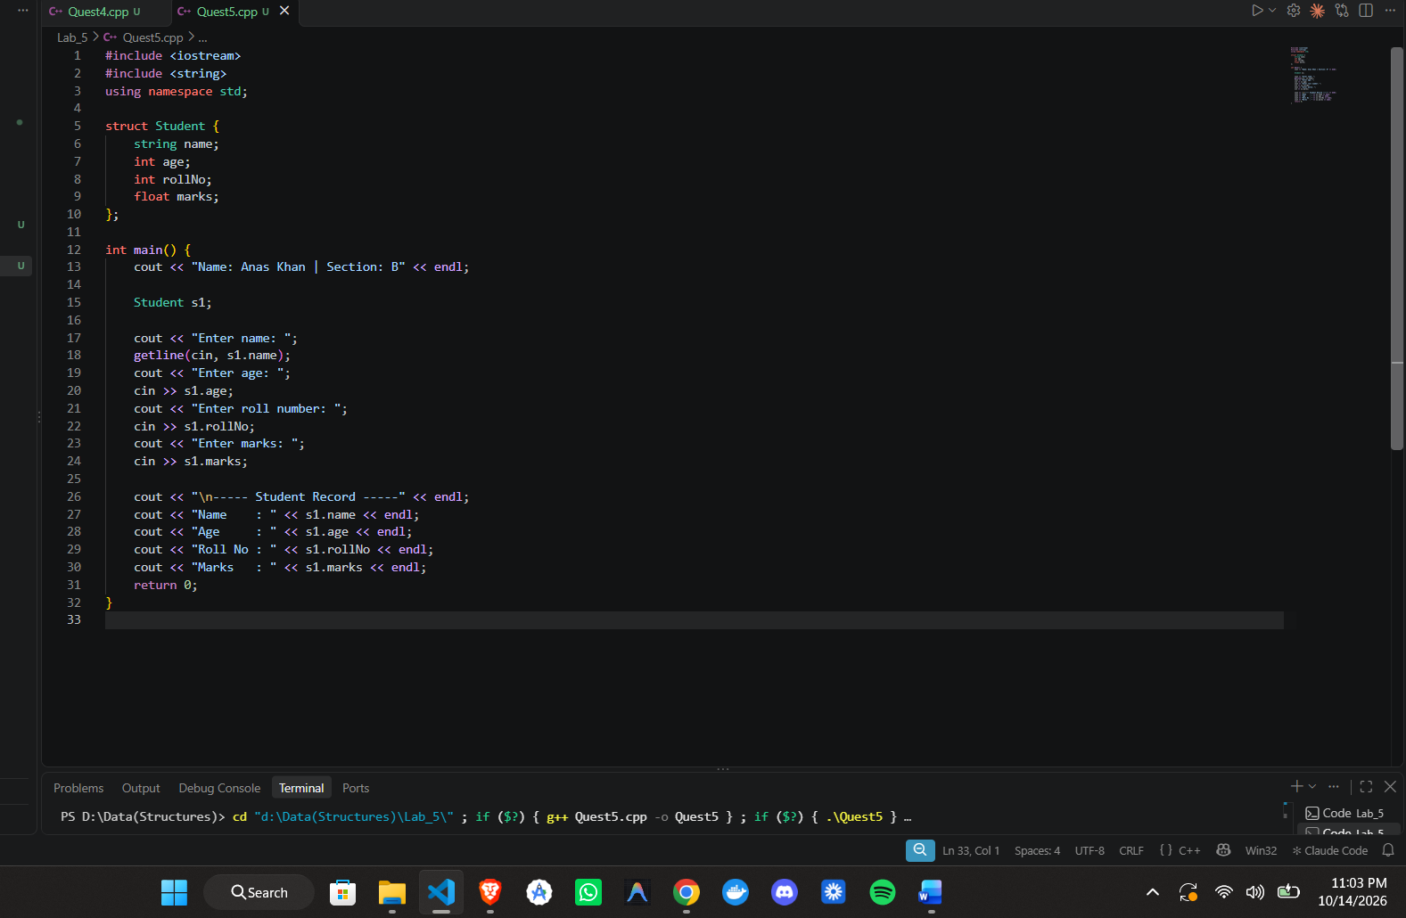
Output Screenshot:
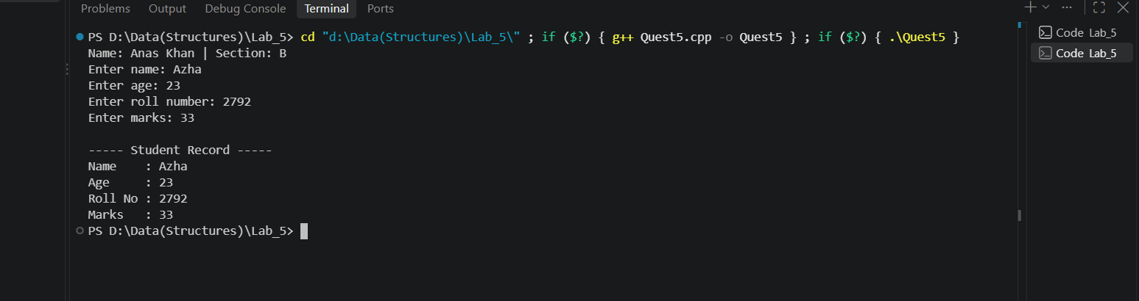

TASK 3: Dynamic Array with Average

Task Statement: Ask the user for n, allocate an integer array dynamically, input n values, calculate their average, then release the memory.
Program:

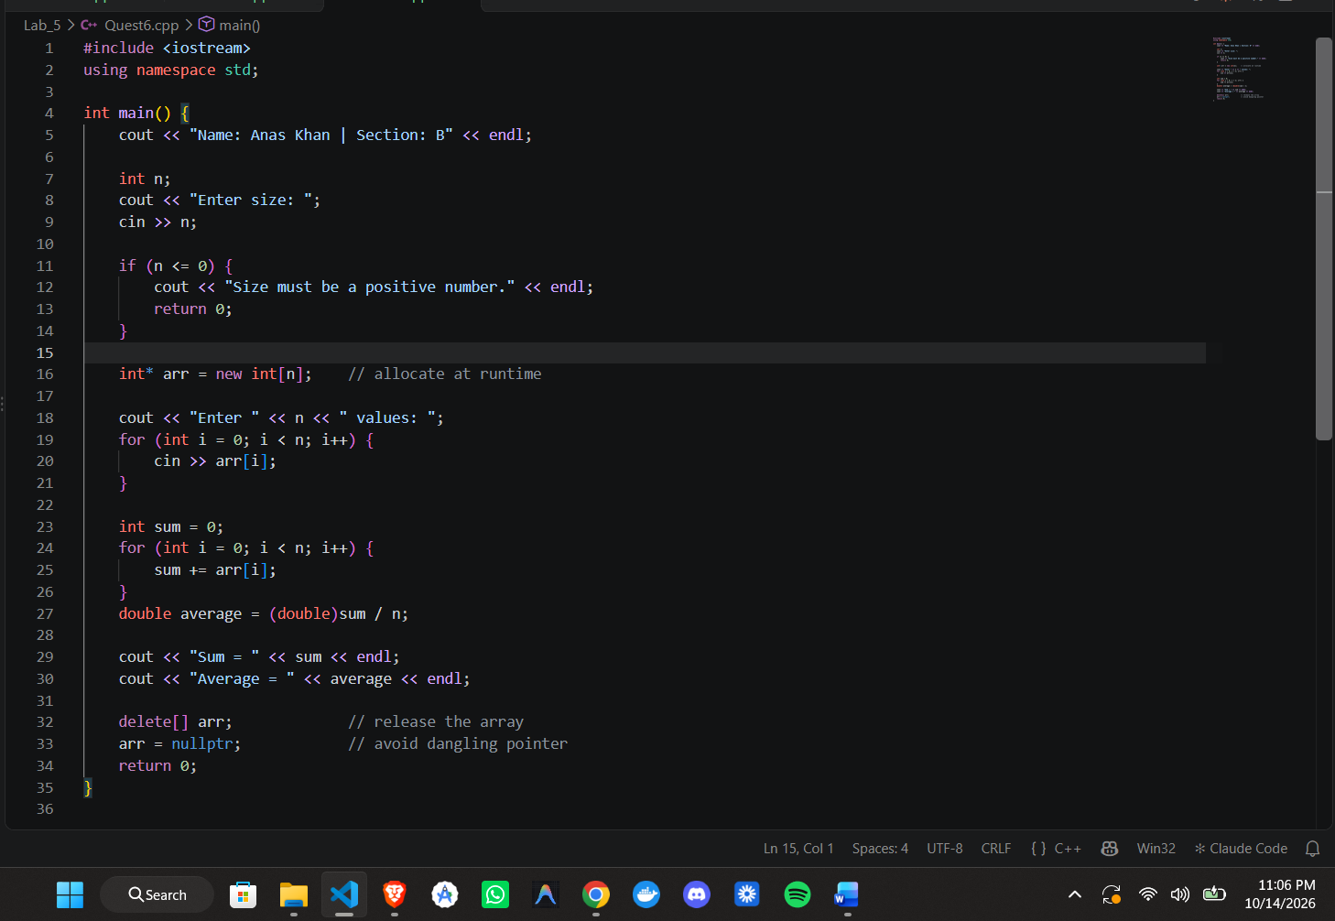
Output Screenshot:
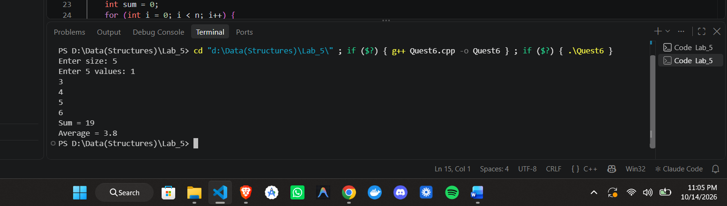

TASK 4: Represent an Empty Linked List
Task Statement: Define the Node structure with int data and Node* next. In main(), create only the head pointer and initialize it to nullptr. Print a message depending on whether the list is empty.
Program:
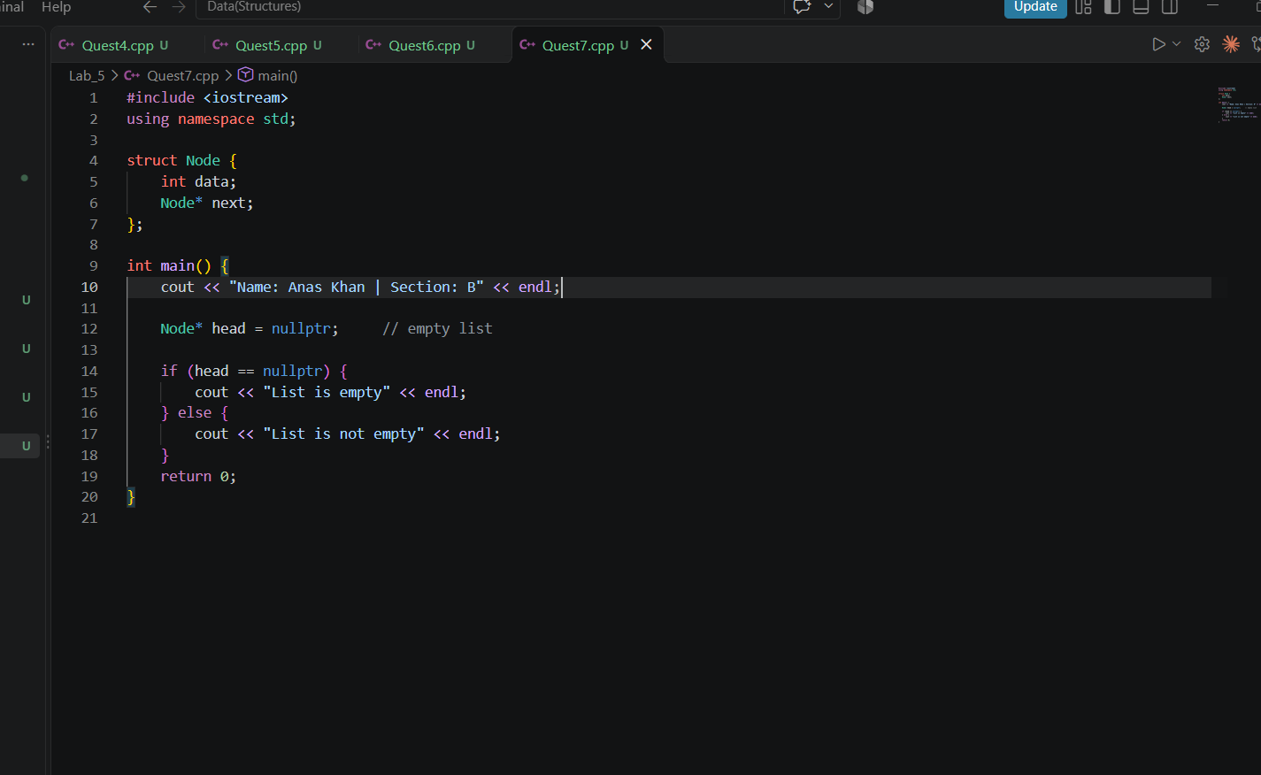

Diagram:
head ───────▶ nullptr

Output Screenshot:
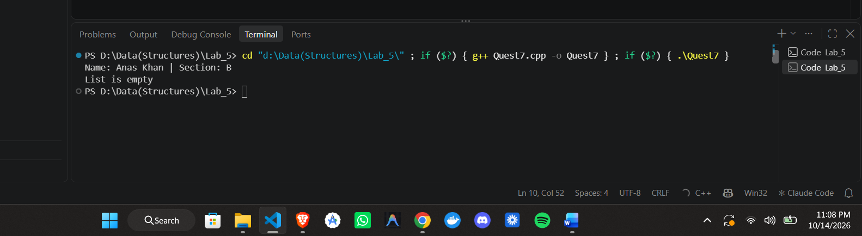

TASK 5: Create a One-Node List
Task Statement: Create one node containing the value 50, set its next pointer to nullptr, make head point to it, and display the value using head->data. Free the node afterwards.
Program:
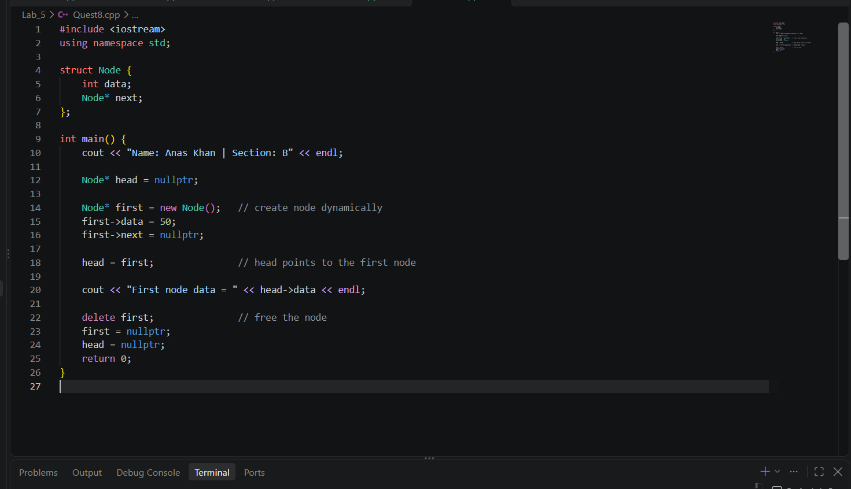

Diagram:
head ───▶ [ 50 | nullptr ]
Output Screenshot:
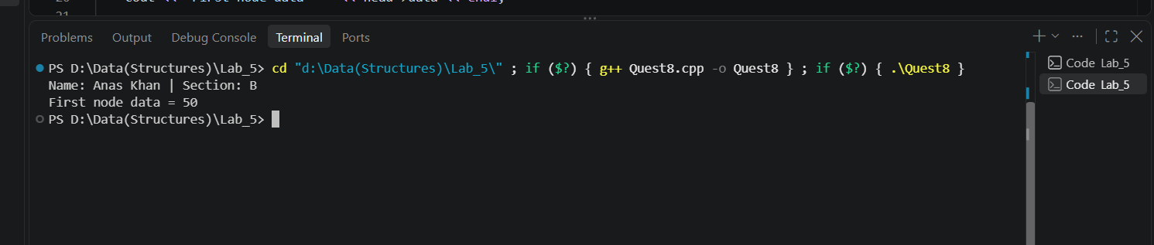

TASK 6: Build a Three-Node Linked List
Task Statement: Dynamically create three nodes containing 15, 25, and 35. Connect them in that order, make head point to the first node, and display all three values.
Program:
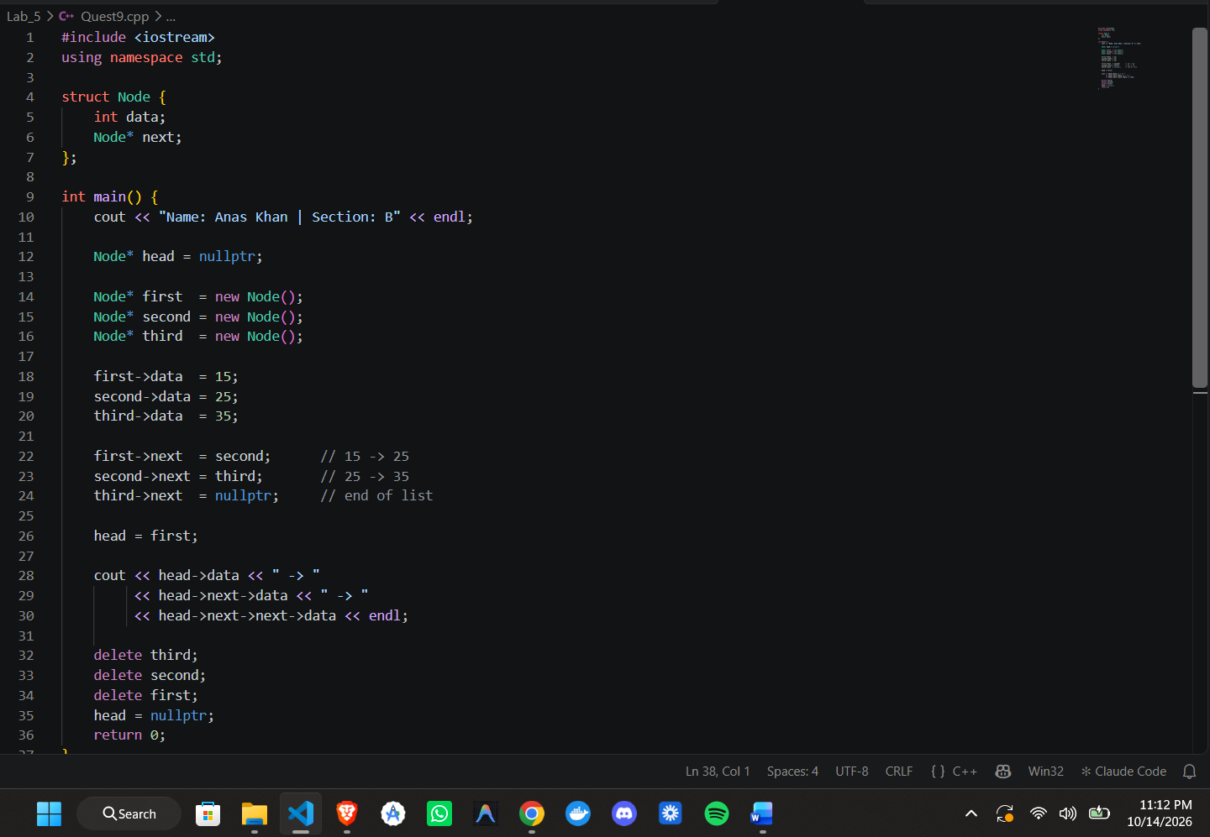
15 -> 25 -> 35
Three-Node Pointer Diagram:
head ──▶ [ 15 | • ]──▶ [ 25 | • ]──▶ [ 35 | nullptr ]
first second third
Output Screenshot:
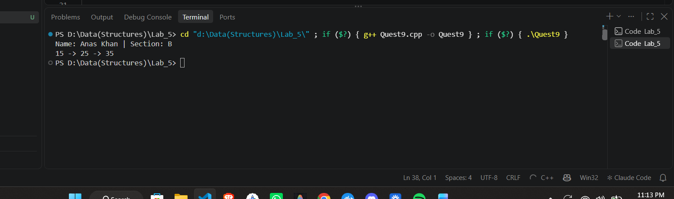

TASK 7: Traverse, Count, and Sum
Task Statement: Create a four-node list containing 10, 20, 30, and 40. Traverse the list once to display all values, count the nodes, and calculate the sum.
Program:
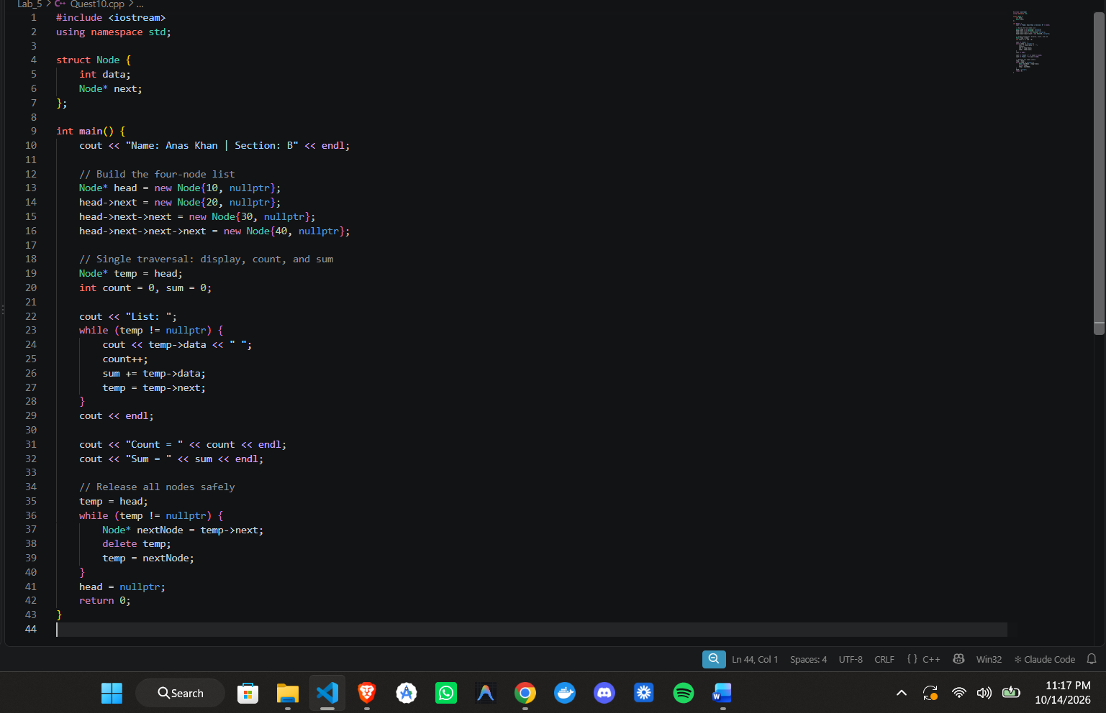
Traversal Dry-Run Table:
Iteration | temp points to | temp->data | count | sum | temp moves to
Start | head (node 1) | – | 0 | 0 | –
1 | node 1 | 10 | 1 | 10 | node 2
2 | node 2 | 20 | 2 | 30 | node 3
3 | node 3 | 30 | 3 | 60 | node 4
4 | node 4 | 40 | 4 | 100 | nullptr
Stop | nullptr | – | 4 | 100 | loop ends
Output Screenshot:
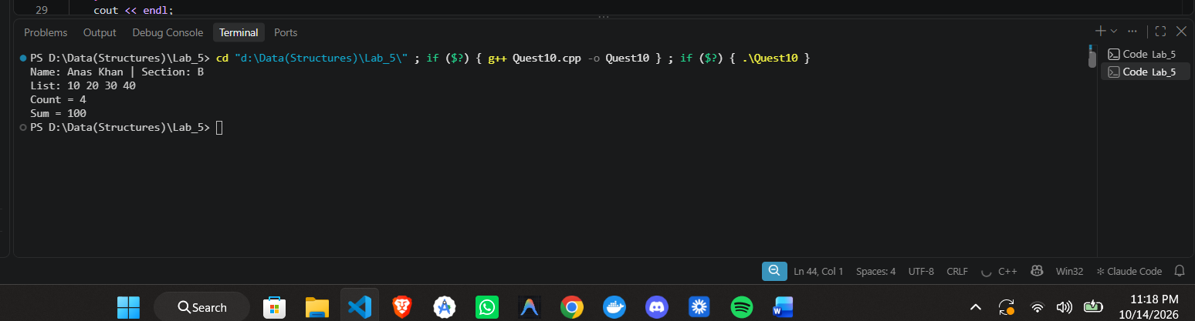

End of Lab Task 5 — Submitted by Anas Khan, Section B, UET Peshawar

